УДК 625.765
¹V.G. Piskunov D.Sc.,
O.V.Volodko,
O. M. Demchyk

DESIGN AND CALCULATION OF AERODROME
COAING WITH HEATED SURFACE LAYERS
КОНСТРУЮВАННЯ ТА РОЗРАХУНОК АЕРОДРОМНОГО
ПОКРИТТЯ З ПОВЕРХНЕВИМИ НАГРІВНИМИ ШАРАМИ
¹National Transport University e–mail: ksm_NTU@ukr.net
The developed constructions with heated by surface layers for aerodromes and auto roads when developed composition of electroconductive concrete reinforced with chemical electrical conductive fibres being used was researched. The experimentally obtained characteristics of ended conductive concrete reinforced with fibers were presented. Calculation by developed heated construction of shell was made.
Розглянута розроблена конструкція нагрівного покриття для злітно-посадочних смуг аеродромів та автомобільних шляхів з використанням спроектованого складу електропровідного бетону, армованого хімічними електропровідними волокнами. Приведені експериментально отримані характеристики складу фіброелектробетону. Виконані розрахунки розробленої нагрівної конструкції покриття.
Key words: Airport runway, development engineering, anti-icing coating, fibrous electro conducting concrete (“fiberbetel”), chemical electro conducting fiber, hardness, strength

Introduction
Systems for heating surface layers of airport runways have been designed to prevent formation of slipperiness and sleet upon the aerodrome coating and to ensure safe operating of airfield in winter. Absence of standards and classification of constructions based on this criterion may be explained by the complicacy of the problem which is not only scientific but techno-economic as well. Thus the research in this sphere may be considered both timely and perspective.
Analysis of research and publications
There exists a heating construction of airport runway [1], which has a basis made of plated concrete and the heating system constructed of metal pipes embedded in concrete. The pipes are placed in longitudinal direction of runway and equipped with pump system to feed the heat-transfer agent. Heated water is used as the heat-transfer agent. (Fig.1).
A drawback of the mentioned technical decision consists in low safety of pipe lines, substantial operating expenses on hermetic pipe lines sealing, high costs of repair-and-renewal operations and exceeding expenditure of energy on sustaining the marked temperature of heat-transfer agent within the system.
Inexpedient consumption of energy caused both by heating of the shell and lower layers and consumption of heat by the ground basis is a serious drawback of the mentioned design as well.

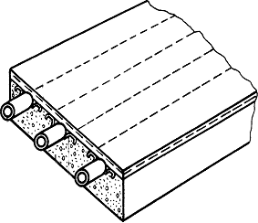
2
1
3
4
Fig.1. Construction design of heated airport runway with pump system feeding the heat-transfer agent to pipes
1 – two-layer bimetallic composite sheet with aluminum upper layer; 2 – galvanized pipes; 3 – plated basis; 4 – embedded elements
There also exist heating constructions with discrete heating elements (metallic wires, fixtures, and separate resistors) that are too difficult to implement. For instance, one may consider the anti-icing coating [2] made in form of non-conducting net-structure where electro conducting elements made of steel band are pulled through the reinforcing ribs. Each reinforcing rib has openings for heating elements (Fig. 2).

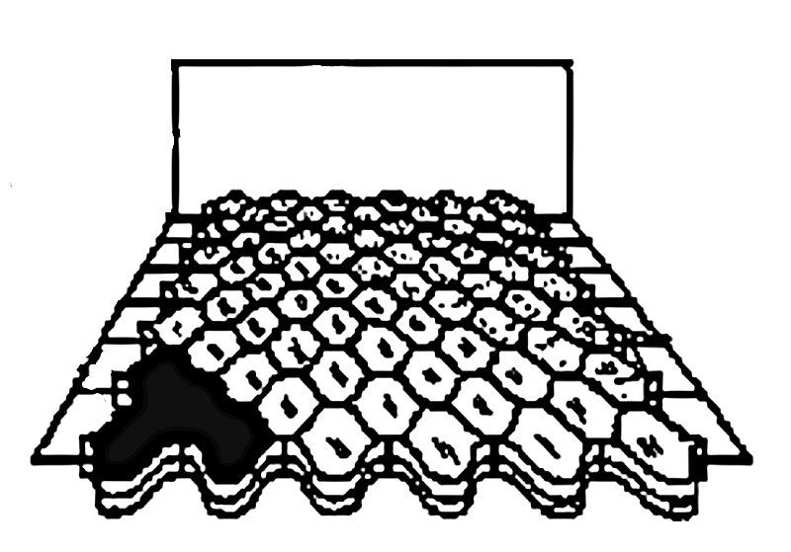
Fig. 2. Structure of the anti-icing coating
1
2
3
1 – power supply; 2 – heating elements; 3 –non-conducting net-structure with sand or grit filling
The top of shell is coated with a layer of asphalt-concrete.
The mentioned construction is pretty complicated in technology of mounting and is of low upkeep properties.
The effective method of heating the airport runway coating is presented by application of special electro conducting composite material based on concrete matrix reinforced with fibers, the so called “fiberbetel” (“fibrous electro conducting concrete”).
The analysis of both domestic and foreign researches dealing with development of composite concrete with concrete matrix reinforced with discrete metal fibers – steel fibrous (researches carried by Lobanov N. A., Staroselskyi A. A., Sopylniak A. V., Sunak P. O., Nilsen L.E., Chen P.E. etc) makes it possible to draw the conclusion that concrete matrix of the mentioned material notwithstanding its high compressive and flexural strength, crack growth resistance and electro conducting properties can hardly be accepted as a suitable coating for aerodromes and highways due to high cost of steel fibrous. It is a well-known fact that the world iron ore reserves are decreasing annually and thus it is impossible to predict the further price of rolled iron and steel fibers.
The importance of application of composites based on mineral fibers - binding and basaltic, glass or carbon fibers – exhibiting stable characteristics, such as: high compressive and flexural strength, shock resistance, crack-resistance, weather resistance and freeze resistance, fire resistance, waterproof and nonmagnetic properties, and electrochemical corrosion resistance, becomes all the more acute. Classification of the mentioned composite materials used in building the heated coating for aerodromes and highways is presented in the paper [3].
Statement of problem
The modern road building industry requires development of new competitive materials and constructions. The aim of the given paper is highlighting the designed airfield coating with heated shell layers using the layer made of electro conducting fibrous. It also deals with calculation of strength of the mentioned construction.
Design and calculation
The authors designed the heated airfield coating using the developed and experimentally researched composition of the electro conducting fibrous, reinforced with chemical electro conducting fibers. Existing electro conducting concretes with matrix reinforced with discrete chemical electro conducting fibers [4,5] exhibit low mechanical strength and abrasion resistance. In order to increase mechanical strength special composites with complex reinforcement of matrix were developed. With this aim the matrix was reinforced with discrete chemical electro conducting fibers and fiberglass. The glass and chemical electro conducting fibers are in no way inferior to best makes of steel and they are extremely effective in reinforcing of concrete. Alkali-resistant fiberglass added into resistance material chemically interacts with hardening concrete. As a result the surface becomes covered with dense layer of new formations that merge with crystalline phase of concrete matrix and form a monolith. Thus this process creates a stable reinforcing effect within the resistance material and increases its mechanical strength and abrasion resistance. One of the mentioned designed compositions was used in engineering design of the heated coatings. This composite contains chemical electro conducting fibers, cement, high-silica sand, fused alumina, alkali-resistant fiberglass and water. Addition of fused alumina considerably increases longitudinal modulus of elasticity. Its coefficient of heat conduction is almost 20 times as big as the coefficient of heat conduction of high-silica sand. Due to this factor the additional technical effect leading to reduction of destructive processes and stresses within the composite is obtained. This effect may be explained by the fact that increase of coefficient of heat conduction of material favors quick export of heat from local source of heating to periphery and leads to averaging of temperature within the bulk of material.
The appropriateness of application of electro conducting fibrous in engineering design of heated aerodrome and highway coating has been proved by two patents on the designed resistive composite material obtained by the authors [6, 7]. Experimental results of technical tests of the designed electro conducting fibrous concrete are presented in table 1.
Table 1
Physical-mechanical properties of the designed electro conducting fibrous (“fiberbetel”)
Sample No. | Tensile strength in bending, MPa | Compression strength, MPa | Wearing power, g/cm³ | Density g/cm³ | Modulus of elasticity, MPa | Resistivity at  t = (105± 5⁰) C
1 | 9,8 | 32 | 0,14 | 3,2 | 2680 | 210
2 | 10,0 | 30 | 0,18 | 2,8 | 2100 | 130
3 | 8,5 | 24 | 0,22 | 2,52 | 1110 | 60
Control sample | 5,6 | 34,6 | 0,30 | 2,61 | 205 | -
Electro conducting fibrous concrete (“fiberbetel”) was used in the four-layer cluster (sandwich) coating of heated layers covering the hard cement-concrete load-bearing slab of the airfield. (Fig. 3). The layer made of electro conducting fibrous concrete is located beneath the upper layer of cement-concrete coating that undergoes the heating process. Power is supplied to carbon electro conducting mesh underlying the “fiberbetel” layer. The thermal insulation is located beneath the carbon electro conducting mesh to insulate the main load-bearing construction of coating from heating.
d
1
2
3
4
5
6
7
8
Fig. 3. Structure of the heated aerodrome coating
1 – asphalt concrete, h=0,06m, E=0,2∙10⁴MPa; 2 – electro fibrous concrete, h=0,05m, Е=0,21∙10⁴MPa; 3 – carbon fiber mesh, h=0,005m, Е=0,2∙10⁴MPa; 4 – thermal insulation, h=0,03m, Е=12 MPa;5,6,7 – three-layer cement-concrete slab В_{btb}4,4, h=0,54m, Е₅=Е₇=3,53∙10⁴MPa, Е₆=3,04∙ 10⁴ MPa; 8 – cushion course, Е=80 MPa
The designed system of heated coating has been calculated by means of thermal design model for laminated system and deflected mode model for multi-layer slabs on cushion course.
Thermal design of the upper heated layers of aerodrome coating has established the possibility to ensure the heating of its surface up to t = +(2-3)⁰ at the ambient temperature −20 ⁰С (Fig.4).

Fig. 4. Temperature regime of the upper heated layers
Calculation of strength of the aerodrome coating (considered as a multi-layer slab on cushion course) has been based on the model of semi-infinite elastic homogeneous medium. Position of the neutral surface relative to the upper plane is defined by formulas evaluation [8]:
$δ=\sum_{к=1}^{5}{\frac{B_{к}d_{к}}{\sum_{к=1}^{5}{В_{к}}}};$ $В_{к}=\frac{Е_{к}h_{к}}{1−ν_{к}^{2}},$

where: $B_{к}$– tension stiffness of layers, МН/m;
$d_{к}−$ distance from the upper plane to the median plane of layer к, m.
Bending stiffness of the coating cluster of layers is defined by formula evaluation:
$D=D_{к}+B_{к}С_{к}^{2}$,
where: $D_{к}=\frac{Е_{к}h_{к}^{3}}{\text{12}(1−ν_{к}^{2})}$ – bending stiffness of layers, МН∙m;
С_{к} – coordinate of the median plane of layer к relative to neutral surface, m.
Neutral surface is located within layer 7 at distance $δ=$0,4102m from the surface of aerodrome coating.
The following results were obtained concrete are presented in table 2.
Further on a modified method of O.Y. Schechter [9] has been applied and stiffness of coating cluster was presented by generalized formula evaluation
$D=\frac{{\text{Еh}}^{3}}{\text{12}\left(1−ν^{2}\right)},$ (1)
where: h – total thickness of coating, m.

Table 2
Stiffness of coating
Bending stiffness of layers, МН∙m | Distance from upper plane, m | Bending stiffness of layers, МН∙m | Distance from neutral surface to surface of к -layer, m
B₁=128,00 | d₁=0,0300 | D₁=0,03840 | z₁=- 0,4102
B₂=112,00 | d₂=0,0850 | D₂=0,00233 | z₂=-0,3502
B₃= 10,66 | d₃=0,1125 | D₃=0,00002 | z₃=-0,3002
B₄=0,3840 | d₄=0,1300 | D₄=0,00003 | z₄=-0,2952
B₅=4412,5 | d₅=0,2050 | D₅=5,29500 | z₅=-0,2652
B₆=9500,0 | d₆=0,4150 | D₆=71,2500 | z₆=-0,1452
B₇=4412,5 | d₇=0,6250 | D₇=5,29500 | z₇= 0,1548
Stiffness of coating cluster  D = 531,53 МН∙ m |  |  | z₈= 0,2748
Condensed elasticity characteristics of cluster of layers was defined by formula evaluation (1):
$$\frac{Е}{1−ν^{2}}=\frac{\text{12}D}{h^{3}}$$
Design moment at bending is defined by formula evaluation:
$$М=\frac{\text{сP}\left(1+ν\right)}{2π\text{аR}},$$
where: P=0,344 МН – design load on airplane wheel; R=0,27m – radius of circle that equals the wheel track area of the rated airplane; с and а – additional constants of the method.
Taking into consideration that total thickness of cluster of layers h=0,685m, its condensed elasticity characteristics equals 19844, 37 MPa. The moment at bending equal to M=19844, 37MPa was received at loading of the airplane circle track, whereas the allowable design moment equals M=0,196МН.
Tension along the thickness of cluster of layers was defined by formula evaluation:
$$σ=\frac{{\text{ME}}_{к}z_{к}}{D\left(1−ν_{к}^{2}\right)},$$
where: E_{к}, $ν_{k}$ - modulus of elasticity and Poisson's ratio of layer к;
$z_{к}$ – distance from neutral surface to the upper and lowest surfaces of layer к.
Design strength of extension resistance of the lower layer of cement-concrete slab В_{btb}4,4 makes R_{р}= 3,73MPa. Therefore, strength of the bearing slab is guaranteed (Fig. 5).
Conclusions
It is recommended to widely apply the proposed construction in design of the heated aerodrome coating.

Fig. 5. Diagram of stresses (MPa) within the aerodrome slab

References
1. RU Patent No. 2 280 727 C1, Airport heated runway, issued October 7, 1997 to A. S. Krivorotov.
2. RU Patent No. 2 280 727 C1, Anti-icing coating and road building, issued June 27, 2006, Bulletin No.21 to I. J. Husainov, D. V. Dolgov, E. S. Pshenichnikova.
3. V.G. Piskunov, O.V.Volodko, A. I. Porkhunov. Composite materials for building of heated highway and airport runway coating, Riga, “Mechanics of composite materials”, 2008, Vol.44. – No. 3. – 317-326.

4. SU Certificate of authorship No.913460 International class Н 01 3 7/00. Resistance material, issued in 1980 to A. K. Severin, L. A, Serdiuk, O. D. Filenko.
5. SU Certificate of authorship No. 1429826 International class Н 01 3 7/00. Resistance material, issued in 1985 to A. K. Severin, A. I. Porkhunov.
6. UA Patent No. 39376 Н01С7/00, Resistance composite material, issued June 25, 2007, Bulletin No.9. V.G. to Piskunov, O.V.Volodko, A. I. Porkhunov
7. UA Patent No. 39376 Н01С7/00, Resistance composite material, issued February 25, 2009, Bulletin No.4 to V.G. Piskunov, O.V.Volodko, A. I. Porkhunov
8. V.G. Piskunov, V.V.Verizhenko. Linear and non-linear problems of calculation of sandwich constructions, Kyiv, Budivelnyk, 1986. – 175.
9. A. K. Byrulia. Handbook for highway engineer. – M., Avtotransizdat,1958.–439.

