ISSN 1561-6894

NR 25 (93) 2013

Nauka і Studia
Przemysl Nauka і studia 2013

Fysun Iryna
associate professor of department offinances Poltava university of economy and trade

RISKS ARE IN SMALL BUSINESS: FUNCTIONS, MANAGEMENT METHODS AND REINSURANCE
Summury
In the article economic essence of risks is considered in small business, their kinds and functions, grounded necessity of their authentication and suggestions are given in relation to an effective management by them by application of the system them reinsurance.
Keywords: risk, enterprise risk, functions of risks, authentication, methods of decline of influence of risks, reinsurance

I. Introduction
Development of domestic small business acquires in the modern terms of socioeconomic development of Ukraine of important value. However, such activity is indissolubly related to the risks of economic, natural, economic technical technological and criminal character. In accordance with statistical information million of people in the whole world try to become businessmen, but hundreds of thousands of small enterprises halt the existence every year. Enterprise risks always are threat for achievement of primary purposes of businessman, and consequently need authentication, search of effective methods of decline of their influence, on development of small business and providing of insurance guarantees businessmen.
The questions of development of theory and practice of functioning of enterprises of small business repeatedly violated in the labours domestic research workers and practices, in particular K. Vaganov, O. Kirichenko, D. Pavlogradskiy, M. Pisarevskiy, O. Steshenko, A. Stukalo, G. Yusupova et al. However, on a present tense, in the special attention the questions of authentication of risks need in small business, methods of decline of their influence and necessity them reinsurance, as an effective method of their management.

II. Raising of task
Coming from foregoing, in modern operating of domestic economy conditions important is a search of methods of diminishing of influence of enterprise risks for an assistance development of small business in Ukraine.
The purpose of the article is research of theoretical principles of essence of risks in small business, their kinds, authentication and development of practical suggestions, in relation of their management by application of the system their reinsurance.

III. Results
It is well-proven that in the general understanding a risk can be examined as a danger or uncertainty in any sphere of economic activity and social-economic life. Legitimate is determination of risk as activity, related to overcoming of vagueness in the situation of inevitable choice, in the process of which possibility is in number and high-quality to estimate probability of achievement of the supposed result and deviation from a purpose.
An enterprise risk can be determined as a situation in entrepreneurial activity which does not eliminate probability of origin of unforeseeable consequences (possible deviation from aims, desired result; losses of part of incomes).
Distinguish the certain types of enterprise risks. In particular, I. Shumpeter offers such their groups: 1) risks, related to the possible technical failure of production, including the danger of loss of material welfares, descendant natural calamities; 2) risks which became investigation of absence of commercial success [1].
Taking into account considerable influence on entrepreneurial activity, enterprise risks need certain efficiency, to their division after specific signs, that are classifications. There are the various going near classification of risks in small business. As a rule, enterprise risks classify depending on an object, fixed in basis of their classification [2].
As a result of generalization of scientific researches basic classification of enterprise risks can be presented as follows:
- after reason of origin enterprise risks divide into such which are related to economic activity, on risks, which are related to the face of businessman and risks, related to the lack of state information external environment;
- after a sphere origins select external risks, which are directly unconnected with activity of businessman (unforeseen changes of legislation; instability of the political mode is in the country of activity, losses, which arise up as a result war, nationalization, strikes, introduction of embargo) and internal risks, which arise up as a result of uneffective management, erroneous marketing policy and inwardly brandname abuses.
- on duration in time distinguish brief risks, which threaten a small enterprise during the certain cutting-off of time (transport risk during transportation of load, risk of non-payment on a concrete operation) and permanent risks which continuously threaten entrepreneurial activity (a risk of non-payment is in a country with the imperfect legal system; a risk of destructions of buildings is in a district with an enhanceable seismic danger);
- after a degree the threats of bankruptcy provide for: a possible risk is a threat of complete loss of income from realization of separate project or from entrepreneurial activity on the whole; critical risk - related to the danger of losses in size of charges on realization of concrete type of entrepreneurial activity or separate operation and catastrophic risk which is characterized a danger, by the threat of losses in a size, which even or exceeds all of the property state of businessman.
- after the degree of legitimacy an enterprise risk can be justified (legitimate) - possible in concrete industries of activity (research projects) and unjustified (illegal) - impermissible in separate industries of activity (atomic energy) (rice. 1).
In addition, distinguish such types of enterprise risks: political risk which shows up in possibility of origin of losses or reduction of profit which is investigation of public policy of country of activity margins; technical risk which is determined the degree of organization of production (risks of losses are as a result of negative results of research and designer works, low technological manufacturabilities); production risk, which is related to the production of goods, commodities and services, and realization of any types of production activity (risk of the uneffective use of raw material, growth of prime price, increase of losses of working hours); commercial risk, which arises up in the process of realization commodity and services, mined-out or purchased a businessman (risks are related to realization of commodity, his transporting, purchasing power of buyer and force-majeure circumstances) [3].
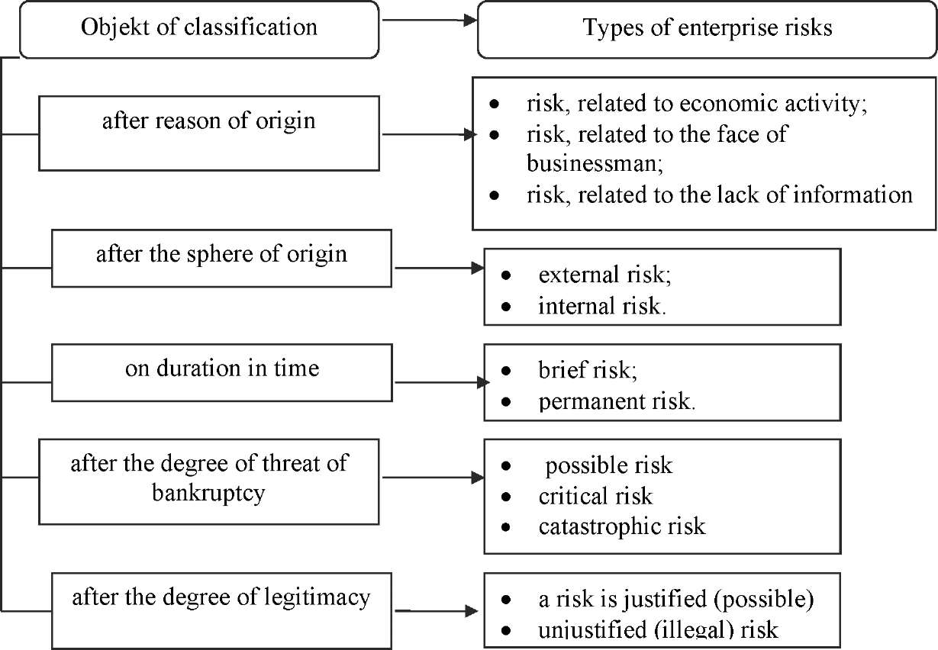

Rice. 1. Classification of enterprise risks
Not because of that risks in small business make a threat for functioning actually of small enterprise, however, they play certain functions, which can be examined as such which have a mediated positive influence for the course of business.
In particular, to such functions it is expedient to take an innovative function, which appears in stimulation of search of ways of untraditional decision of problems which arise up for the subject of small business under act of certain risks. A regulative
function provides possibility of implementation of role of catalyst a risk during realization of economic operations (innovative search and enterprise activity). Enterprise risks play and protective function for a small enterprise which shows up in the necessity of insurance of the expected risks. The compensative function of enterprise risks provides compensative success (additional, by comparison to planned, income in the case of successful result). A socio-economic function shows up in that due to a risk and competition task forces of effective proprietors are selected. And finally, a risk presence predetermines the necessity of choice in the process of analysis from the alternative variants of activity of enterprise of small business most profitable and the display of analytical function of enterprise risks is thus provided [4].
However, without regard to a certain stimulant the role of enterprise risks for activity of small enterprise, risks always are a threat for achievement of his primary purposes. Taking into account it, enterprise risks need authentication and search of the most effective methods of management by them.
The process of management risks in small business has two basic constituents: authentication of risk is with the purpose of their exposure and decline of degree of influence of risk. That touches the first constituent, for the exposure of risk it is necessary to identify him. In the wide understanding authentication (from Latin identificus - identical) can be examined from two positions: 1) equation, assimilation; 2) establishment on the basis of certain signs of identity of different objects.
In relation to enterprise risks authentication helps their exposure with the purpose of search of management methods by them (rice. 2).
In addition, authentication of risks in small business helps to find out legal and legal factors which influence on activity of small enterprise, to which it is legitimate to take the followings: licensing; patent rights; errors are in contracts; external lawsuits; internal lawsuits; force-majeure circumstances.
The next constituent of process of management enterprise risks is a search of methods for the decline of risk degree. The methods of decline of risk are most widespread presented on rice. 3. In addition, to the methods of degree of decline of enterprise risks it costs to take the use of information (information) on risks, namely : databases are in relation to past experience of small enterprise; current databases; archives [5].
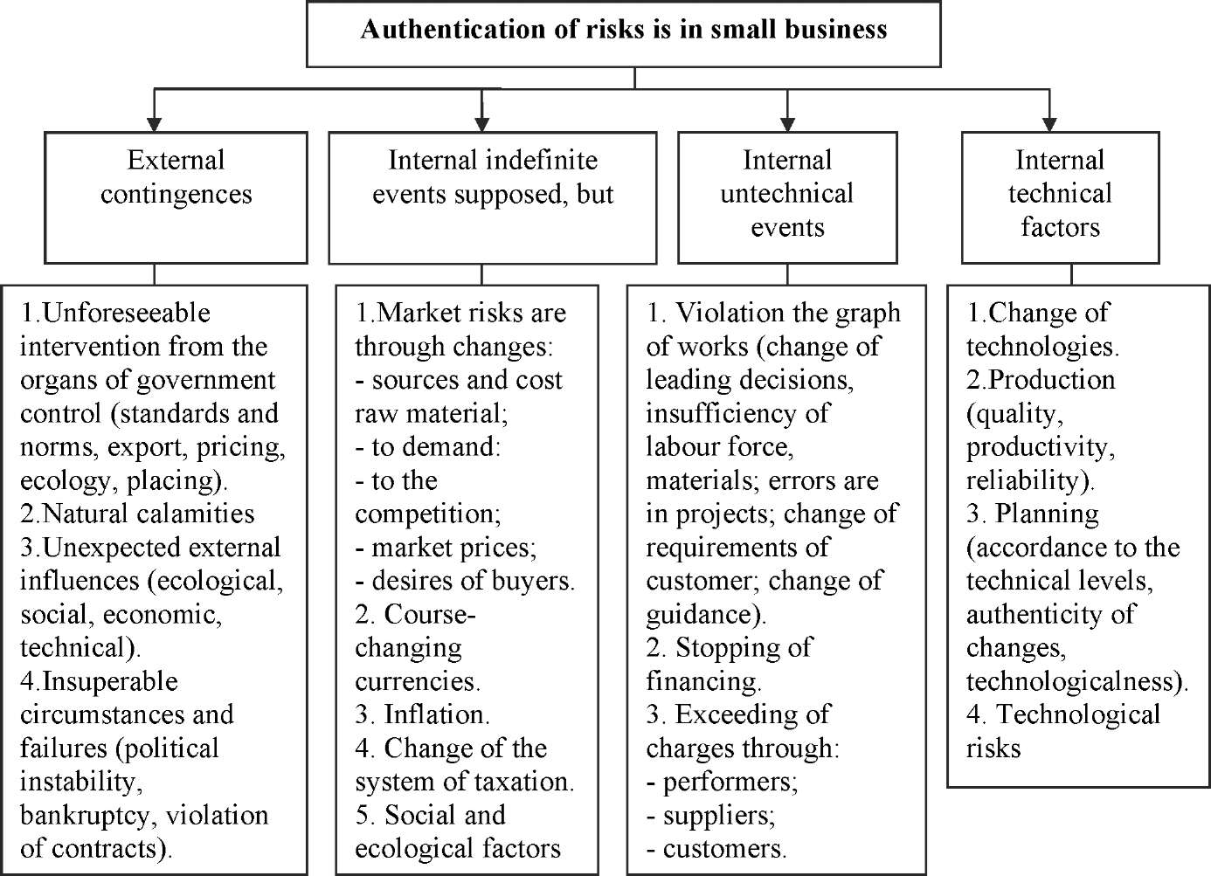
Rice. 2. Authentication of risks is in small business
Coming from that a risk arises up during realization of any entrepreneurial activity and related to the production and realization of products, commodities and services, by commodity-money and financial operations, in the conditions of market, exceptional actuality acquires insurance of enterprise risks. Insurance is not only the method of protection of charges of enterprise from destructive natural calamities but also mean of defence, from the unfavorable change of the economic state of affairs. It is directed on protecting of businessmen from negative factors which interfere with achievement of the put aims of enterprise of small business and receipt of income. Insurance of enterprise risk can be defined as a system of compensation of losses by insurers in case of occurring of accidents insured from the special insurance funds, which are formed due to insurance payments which are paid insure-businessmen [6].
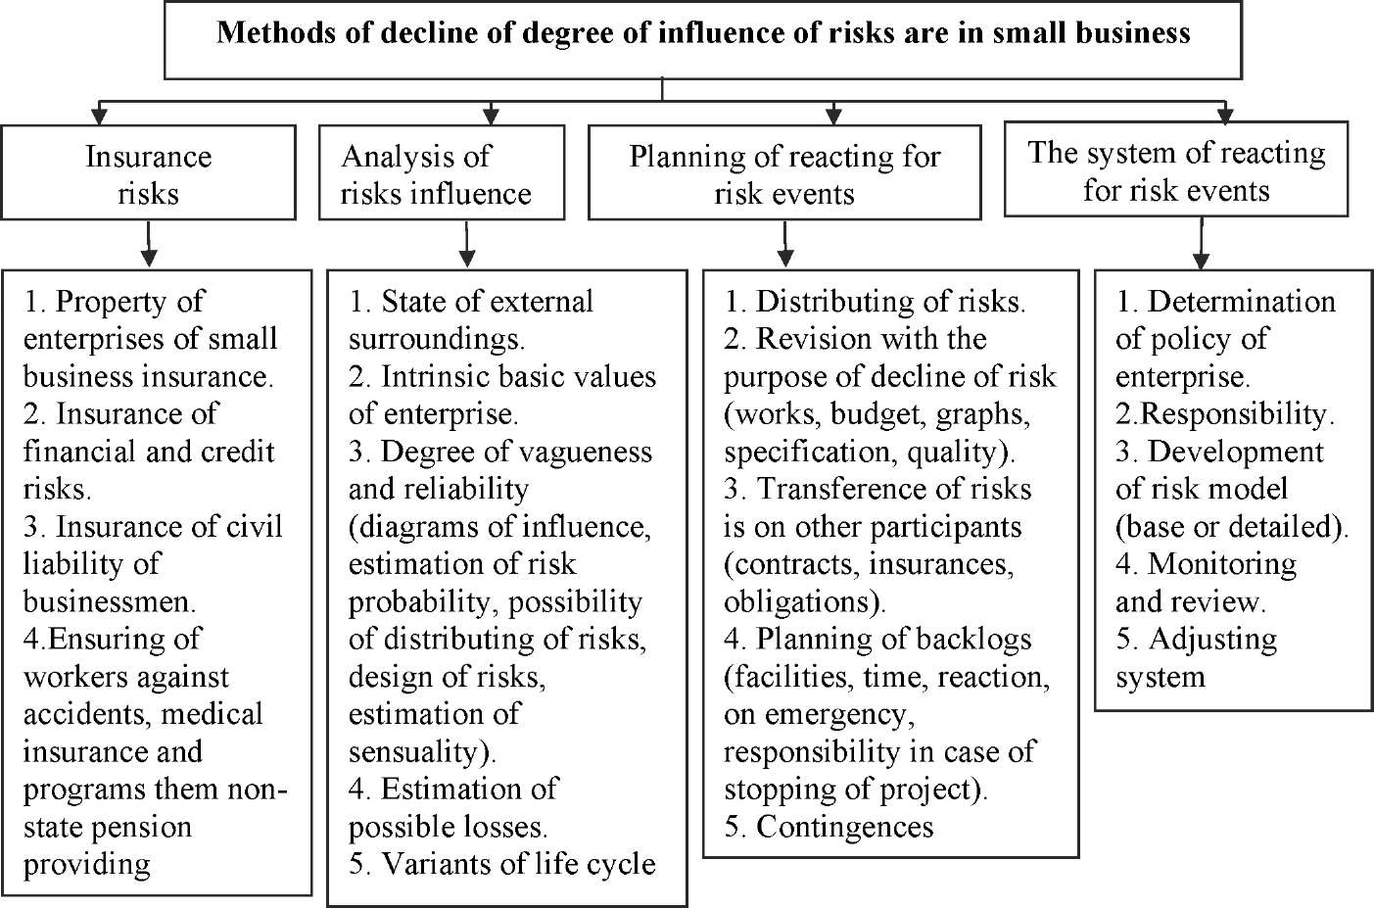
Rice. 3. Methods of decline of degree of influence of risks are in small business
Taking into account the types of risks in small business, insurance of enterprise risks is an aggregate of property, insurance of responsibility and personal insurance insurance. Taking into account that consequences of such risks can be extraordinary and their compensation can negatively affect financial reliability of the Ukrainian insurers, there is a necessity them reinsurance. Especially such mechanism will be effective at the offensive of risks in small business, which are caused natural calamities, in fact in this case it is necessary it will be simultaneously to recover considerable on a volume losses insurers to plenty of insure-businessmen. As influence of such risks is simultaneously tested by the far of subjects of small business in a country, there is expedience of reinsurance of these risks in foreign reinsure, which have a high level of reliability. Thus, the redistribution of risks in small business by application of the system of reinsurance will provide an effective management by them and will give a guarantee domestic businessmen in coverage them possible losses.

IV. Conclusions
1. Risk in small business it is expedient to determine as a situation in entrepreneurial activity which does not eliminate probability of origin of unforeseeable consequences for a small business entity (possible deviation from aims,
desired result; losses of part of incomes). Taking into account considerable influence on entrepreneurial activity, enterprise risks need classification on specific signs, that allows to identify them in the future and to find the most effective methods of management by them.
- The process of management risks in small business has two basic constituents: authentication of risk is with the purpose of their exposure and decline of risk degree. Authentication of enterprise risks helps their exposure with the purpose of search of management methods by them and is the mean of determination of legal and legal factors which influence on activity of small enterprise. The most widespread methods of decline of influence of risk on entrepreneurial activity is: analysis swim risks, their insurance, planning of reacting, on risk events, system of reacting on risk events, use of information on risks.
- One of effective modern methods of diminishing of influence of risks in small business there is their insurance, which is directed on protecting of businessmen from possible unforeseeable negative circumstances and factors which interfere with achievement of aims of enterprise of small business and receipt of income. Because of possible simultaneous influence of risks on the far of subjects of small business in a country, there is expedience them reinsurance in foreign reinsure with the purpose of redistribution of risks in small business and providing of effective management by them.

The literature
  - Kirichenko O.A. Strategy of development of small and middle business in Ukraine / O.A. Kirichenko, K.G. Vaganov // issues of the day of economy.-2008,-№1,-P. 103-118.
  - Pavlogradskiy D.A. Management of small enterprise a risk / D.A. Pavlogradskiy, O.M. Lozovskiy [Electronic resource], access Mode: http: // www.rusnauka.com.
  - Pisarevskiy I.M. Management risks: train aid / I.M. Pisarevskiy, O.D. Steshenko. it is Kharkov: KHNAMG, 2008. - 124 p.
  - Stukalo A.V. Adaptation of mechanism of socio-economic development of small business to the terms of market economy /A.B. Stukalo // Investments: practice and experience. - 2010. - №2. - P. 37-41.
  - Yusupova G. Franchayzing as an instrument of decline of enterprise risks in small business / G. Yusupova [Electronic resource], access Mode: http: // www.ukrsprava.com.
  - Fisun I.V. Problems of development of production enterprise in Ukraine /I.V. Fisun, O.M. Semenova // the Scientific announcer PUET. Series are economic sciences. Poltava: PUET, 2010. - №5 (44). - P. 139-144.

